**Project Name:** Currency Converter (JAVA)

**Github Link:** https://github.com/projectsforstudents2022/Currency_Converter-JAVA.git

**Why was this project created?**

Being a trader in one nation who wishes to import products from another nation, you figure out the cost of goods in the other nation and the exchange rate between the two currencies. It is only normal to hear about currency conversion if you use currencies for investment purposes. While some people are aware of currency conversion, others are unaware. To convert between two currencies, one must understand the true worth of one currency in relation to the one of another nation.

**What problem is it solving?**

A universal currency converter is an online tool that uses the most recent exchange rates to swiftly and conveniently convert currency values. These currency converters, such as those that quickly change the value of PHP to USD or USD to PHP, are readily available online.

**Entire explanation of project**

* **PROPOSED APPROACH**

The Exchange Rate Converter Project A straightforward desktop application written in Java was created. The Java programming language allows us to develop extremely exciting applications. It includes the Currency Converter. The Java script and resource files are both included in the project system file. The system's user interface is easy to use and fluid. The Exchange Rate Converter Java always has the most recent exchange rate, eliminating any room for error. As far as we are aware, a reliable currency converter is required for every currency exchange or transaction. Because the user has access to a currency converter directly on his computer system, doing business within and outside of the country can be done quickly and in real-time without the risk of making a human error, which is frequently the case in most of these transactions. Currency converters are helpful, simple, accurate, and quick to use in any situation. For accurate and timely information, one can rely on currency converters. Real-time information delivery is a reliable capability. The most recent information on foreign currencies and precious metals is displayed on these systems' user-friendly, visually appealing, and straightforward interfaces. Even better, users can follow all of this data in real time.

* **RESULT**

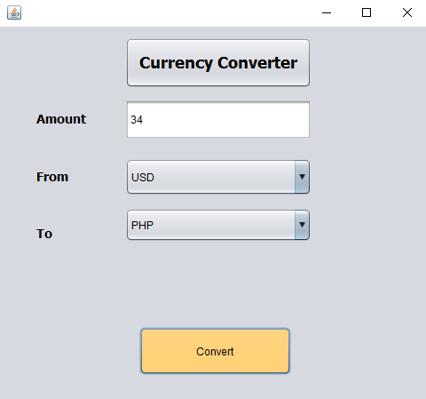

* **CONCLUSION**

The NetBeans IDE was used to construct this Java Project for Currency Converter with Source Code. Travelers that visit other countries on vacation, companies who conduct business abroad or engage in import and export activities, and currency traders can all benefit from conversion. An app or website application known as a universal currency converter enables the rapid conversion of any currency into any other currency.